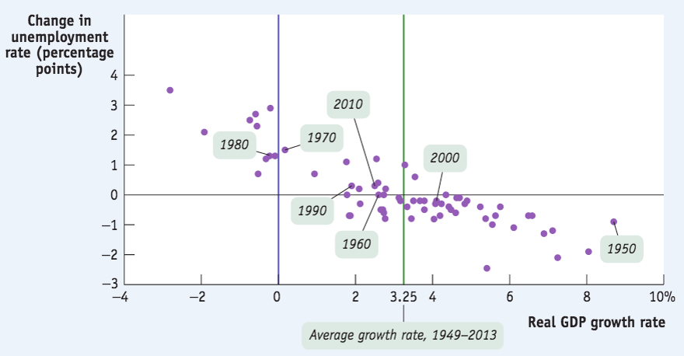

Look at the graph and describe which economic variables are represented.

a What does the [unemployment](https://moodle.unive.it/mod/resource/view.php?id=41013) rate represent?  
b What is the relationship between the two variables?  
c Is the [unemployment](https://moodle.unive.it/mod/resource/view.php?id=41013) rate a good indicator of the current state of the economy?

1. The unemployment rate represents the share of unemployed people, namely working-age people who are jobless, looking for a job (in the last 4 weeks) and available for work, in the labour force. It is calculated as the ratio of unemployed over labour force multiplied by 100.
2. Unemployment is in a negative relationship with real GDP: when GDP rises it falls and vice versa.
3. The unemployment rate is usually considered a good indicator of the current state of the economy, giving information about whether it is in an expansionary or recessionary phase. However, it could either overstate or understate the real performance of the economy: it could overstate it because even in an healthy economy, it takes time to find a job that matches your skills and it could understate it because there are some categories of workers that are not considered unemployed despite being so. These categories are discouraged workers (people who have given up looking for a job because they see little perspective of finding one given the current state of the labour market), marginally attached workers (larger set to which the former belong: people who have been looking for a job in the last 12 months but are not currently doing so in the past 4 weeks) and underemployed workers (people who work part time because of “economic reasons” 🡪 no full time jobs available and, therefore, do not participate in the labour market as much as their potential would allow them to).

Economists observed the only five residents of a very small economy and estimated each one's consumer spending at various levels of current disposable income.

The accompanying table shows each resident's consumer spending at three income levels.

|  |  |  |  |
| --- | --- | --- | --- |
| Individual consumer spending | First tertile | Second tertile | Third tertile |
|  | $0 | $20,000 | $40,000 |
| Andre | 1,000 | 15,000 | 29,000 |
| Barbara | 2,500 | 12,500 | 22,500 |
| Casey | 2,000 | 20,000 | 38,000 |
| Declan | 5,000 | 17,000 | 29,000 |
| Elena | 4,000 | 19,000 | 34,000 |

a) What is each resident's consumption function? What is the marginal propensity to consume for each resident?

b) What is the economy's aggregate consumption function? What is the marginal propensity to consume for the economy?

1. Andre’s consumption function: c = a + MPC x dy 🡪 c = 1000 + 14000/20000 x dy 🡪 c = 1000 + **0.7**dy  
   Barbara: c = 2.500 + 10.000/20.000 x dy 🡪 c = 2.500 + **0.5**dy

Casey: c = 2.000 + 18.000/20.000 x dy 🡪 c = 2.000 + **0.9**dy  
Declan: c = 5.000 + 12.000/20.000 x dy 🡪 c = 5.000 + **0.6**dy  
Elena: c = 4.000 + 15.000/20.000 x dy 🡪 c = 4.000 + **0.75**dy

1. C = 14.500 + 0.69dy

In an economy with no government and no foreign sectors, autonomous consumer spending is $250 billion, planned investment spending is $350 billion, and the marginal propensity to consume is 2/3.

a) Plot the aggregate consumption function and planned aggregate spending.

b) What is the unplanned inventory investment when real GDP equals $600 billion?

c) What is Y*, income-expenditure equilibrium GDP?

d) If planned investment spending rises to $450 billion, what will be the new Y*?

1. **C = 250 + 2/3DY**  
   AEplanned = C + Iplanned = 250 + 2/3DY + 350 = **600 + 2/3 DY**
2. GDP = DY = 600 and AEunplanned = GDP – AEplanned, so AEunplanned = 600 – [600 + 2/3(600)] = 600 – [600 + 400] = **- 400** 🡪 negative unplanned inventory investment, so economy is growing because sales have been more than expected.
3. GDP = AEplanned, so GDP = 600 + 2/3GDP 🡪 1/3GDP = 600 🡪 GDP = 600 x 3 = **1800**.
4. AEplanned = C + Iplanned = 250 + 2/3GDP + 450 = 700 + 2/3 GDP, so GDP = 700 + 2/3 GDP 🡪 1/3GDP = 700 🡪 GDP = 700 x 3 = **2100**